Machine Learning Model Development and Evaluation Report

Introduction
This report outlines the development, evaluation, and comparison of machine learning models for predicting multiple target variables in a sensor dataset. The dataset consists of sensor readings from various equipment, including pressure sensors, temperature sensors, flow sensors, and virtual sensors. The goal was to predict five target variables: cool_cond, valve_cond, pump_leak, hyd_accum, and stable_flag. The project involved data preprocessing, feature engineering, dimensionality reduction, and model training using a variety of machine learning algorithms. The results were evaluated based on accuracy, F1-score, and ROC-AUC metrics.

Data Loading and Preprocessing
The dataset was loaded from multiple text files, each corresponding to a specific sensor. The sensor data was combined into a single DataFrame, and the target variables were appended from a separate file (profile.txt). The dataset contained the following sensors:
- Pressure Sensors (PS1-PS6): 6000 attributes each (100 Hz).
- Motor Power Sensor (EPS1): 6000 attributes (100 Hz).
- Volume Flow Sensors (FS1-FS2): 600 attributes each (10 Hz).
- Temperature Sensors (TS1-TS4): 60 attributes each (1 Hz).
- Vibration Sensor (VS1): 60 attributes (1 Hz).
- Efficiency Factor (SE): 60 attributes (1 Hz).
- Virtual Cooling Efficiency (CE): 60 attributes (1 Hz).
- Virtual Cooling Power (CP): 60 attributes (1 Hz).
The combined dataset had 2205 rows and 43685 columns. After checking for null values, it was confirmed that the dataset had no missing values, ensuring data quality for further processing.
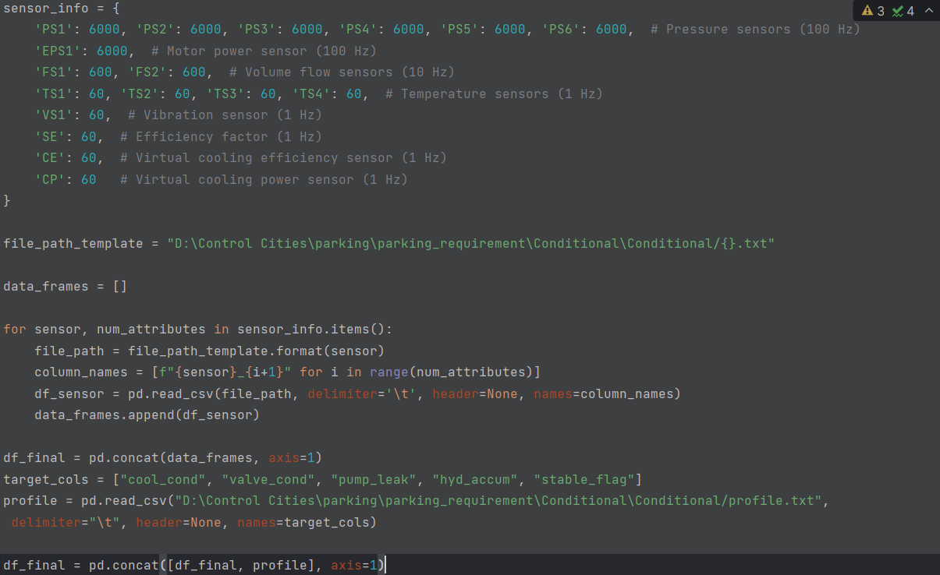
Figure 1 Data Loading

Feature Engineering
- Removing Low-Variance Features: To reduce dimensionality and remove uninformative features, a Variance Threshold was applied with a threshold of 0.05. This step reduced the dataset to 2205rows and 39741 columns, retaining only features with sufficient variance.
- Handling Skewed Features: Skewed features were identified using the skewness measure, and features with an absolute skewness greater than 1 were transformed using the Yeo-Johnson Power Transformer. This step ensured that the data distribution was more Gaussian-like, which is beneficial for many machine learning algorithms.
- Standardization: All features were standardized using Standard Scaler to ensure that each feature had a mean of 0 and a standard deviation of 1. This step is crucial for algorithms sensitive to feature scales, such as SVM and KNN.
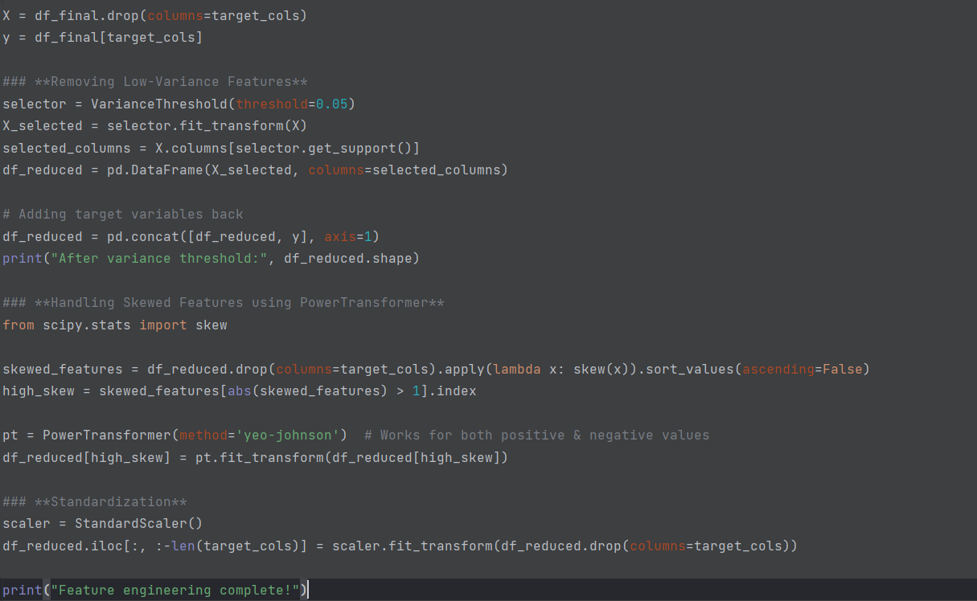
Figure 2 Feature Engineering Step
Dimensionality Reduction (PCA)
To further reduce dimensionality and see the trade between computational efficiency and accuracy, Principal Component Analysis (PCA) was applied to the dataset. PCA retained 95% of the variance, reducing the dataset to 2205 rows and 9 columns. This step was performed to compare model performance with and without PCA.
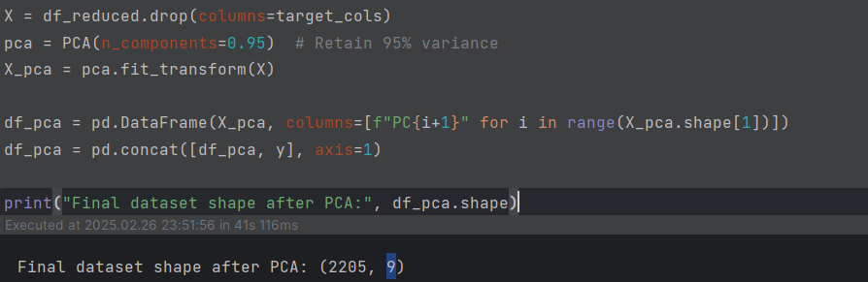
Figure 3 PCA

Model Training and Evaluation
The following machine learning models were trained and evaluated:
- Random Forest Classifier
- Light GBM Classifier
- Gaussian NB (Naive Bayes)
- K Neighbors Classifier (KNN)
- Gradient Boosting Classifier
- SVC (Support Vector Classifier)
- Logistic Regression

Evaluation Metrics
The models were evaluated using the following metrics:
- Accuracy: Total overall accuracy of the model.
- F1-Score: Harmonic mean of precision and recall (weighted for multi-class problems).
- ROC-AUC: Area under the ROC curve (binary and multi-class).

Results and Comparison

Results with PCA
The table below summarizes the performance of models with PCA applied:
Target | Model | Accuracy | F1-Score | ROC-AUC
cool_cond | RandomForest | 0.9841 | 0.9841 | 0.9979
 | LightGBM | 0.9932 | 0.9932 | 0.9995
 | NaiveBayes | 0.9773 | 0.9774 | 0.9958
 | KNN | 0.9864 | 0.9864 | 0.9965
 | GradientBoosting | 0.9841 | 0.9841 | 0.9984
 | SVM | 0.9773 | 0.9773 | 0.9977
 | LogisticRegression | 0.9887 | 0.9887 | 0.9967
valve_cond | RandomForest | 0.8027 | 0.8035 | 0.9372
 | LightGBM | 0.7596 | 0.7599 | 0.9137
 | NaiveBayes | 0.5057 | 0.3783 | 0.5986
 | KNN | 0.712 | 0.7187 | 0.9125
 | GradientBoosting | 0.712 | 0.6994 | 0.8663
 | SVM | 0.5102 | 0.3497 | 0.6692
 | LogisticRegression | 0.5079 | 0.3501 | 0.6016
pump_leak | RandomForest | 0.941 | 0.9411 | 0.9917
 | LightGBM | 0.9524 | 0.9526 | 0.9946
 | NaiveBayes | 0.5737 | 0.4694 | 0.6407
 | KNN | 0.9592 | 0.9592 | 0.9865
 | GradientBoosting | 0.9229 | 0.9225 | 0.9856
 | SVM | 0.644 | 0.5704 | 0.853
 | LogisticRegression | 0.5941 | 0.4857 | 0.7653
hyd_accum | RandomForest | 0.8549 | 0.8554 | 0.9599
 | LightGBM | 0.8481 | 0.8493 | 0.9667
 | NaiveBayes | 0.4399 | 0.3912 | 0.6559
 | KNN | 0.8481 | 0.8482 | 0.9515
 | GradientBoosting | 0.805 | 0.8051 | 0.9523
 | SVM | 0.5125 | 0.4733 | 0.8121
 | LogisticRegression | 0.4649 | 0.407 | 0.6344
stable_flag | RandomForest | 0.9546 | 0.9543 | 0.9879
 | LightGBM | 0.9569 | 0.9566 | 0.9855
 | NaiveBayes | 0.6712 | 0.6785 | 0.7302
 | KNN | 0.9728 | 0.9727 | 0.9841
 | GradientBoosting | 0.9342 | 0.9334 | 0.9734
 | SVM | 0.9093 | 0.9072 | 0.9137
 | LogisticRegression | 0.7551 | 0.745 | 0.7906

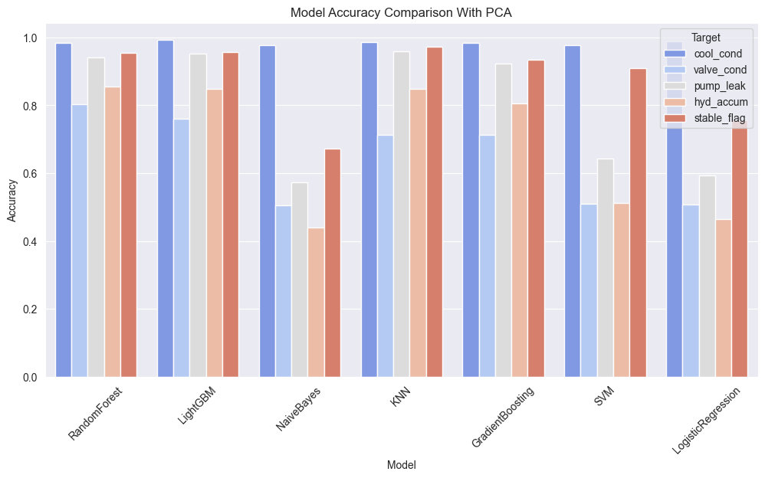
Figure 4 Model Performances With PCA

Results Without PCA
The table below summarizes the performance of models without PCA:
Target | Model | Accuracy | F1-Score | ROC-AUC
cool_cond | RandomForest | 1 | 1 | 1
 | LightGBM | 1 | 1 | 1
 | NaiveBayes | 0.9592 | 0.959 | 0.9693
 | KNN | 0.9909 | 0.9909 | 0.9931
 | GradientBoosting | 0.9977 | 0.9977 | 1
 | SVM | 0.9955 | 0.9955 | 0.9999
 | LogisticRegression | 0.9977 | 0.9977 | 1
valve_cond | RandomForest | 1 | 1 | 1
 | LightGBM | 1 | 1 | 1
 | NaiveBayes | 0.9728 | 0.9721 | 0.9915
 | KNN | 0.966 | 0.966 | 0.9984
 | GradientBoosting | 1 | 1 | 1
 | SVM | 0.8844 | 0.8658 | 0.9956
 | LogisticRegression | 0.9977 | 0.9977 | 1
pump_leak | RandomForest | 0.9977 | 0.9977 | 0.9999
 | LightGBM | 0.9977 | 0.9977 | 1
 | NaiveBayes | 0.5964 | 0.4894 | 0.5574
 | KNN | 0.9728 | 0.9727 | 0.9975
 | GradientBoosting | 0.9932 | 0.9932 | 0.9999
 | SVM | 0.9864 | 0.9864 | 0.9978
 | LogisticRegression | 0.9909 | 0.9909 | 0.996
hyd_accum | RandomForest | 0.9751 | 0.9747 | 0.9992
 | LightGBM | 0.9864 | 0.9863 | 0.9996
 | NaiveBayes | 0.4036 | 0.3568 | 0.5727
 | KNN | 0.9161 | 0.9165 | 0.9758
 | GradientBoosting | 0.9751 | 0.9747 | 0.9974
 | SVM | 0.7528 | 0.7597 | 0.9412
 | LogisticRegression | 0.9705 | 0.9709 | 0.9985
stable_flag | RandomForest | 0.9683 | 0.9682 | 0.9945
 | LightGBM | 0.9705 | 0.9705 | 0.9943
 | NaiveBayes | 0.8073 | 0.812 | 0.8503
 | KNN | 0.9751 | 0.9749 | 0.9885
 | GradientBoosting | 0.9705 | 0.9705 | 0.9931
 | SVM | 0.932 | 0.9313 | 0.9847
 | LogisticRegression | 0.9592 | 0.9592 | 0.9933

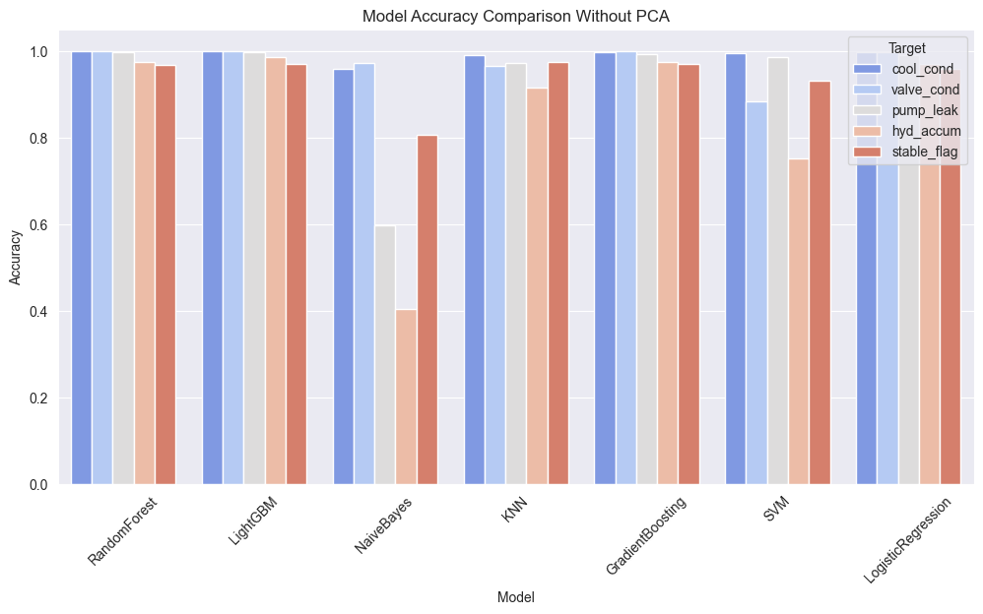
Figure 5 Model Comparison Without PCA

Overall Performance for Each Label
cool_cond
- Best Model: LightGBM (Accuracy: 1.0, F1-Score: 1.0, ROC-AUC: 1.0 without PCA).
- Performance: All models performed exceptionally well, with accuracy above 95%. PCA slightly reduced performance for some models. 5.3.2
valve_cond
- Best Model: RandomForest (Accuracy: 1.0, F1-Score: 1.0, ROC-AUC: 1.0 without PCA).
- Performance: Models like Naive Bayes and SVM struggled with this target, achieving lower accuracy and ROC-AUC. PCA significantly improved performance for most models
pump_leak
- Best Model: LightGBM (Accuracy: 0.9977, F1-Score: 0.9977, ROC-AUC: 1.0 without PCA).
- Performance: LightGBM and RandomForest performed exceptionally well. Naive Bayes had the lowest performance.
hyd_accum
- Best Model: LightGBM (Accuracy: 0.9864, F1-Score: 0.9863, ROC-AUC: 0.9996 without PCA).
- Performance: LightGBM and RandomForest outperformed other models. Naive Bayes and SVM had lower accuracy. 5.3.5
stable_flag
- Best Model: KNN (Accuracy: 0.9751, F1-Score: 0.9749, ROC-AUC: 0.9885 without PCA).
- Performance: KNN and RandomForest performed well. Naive Bayes had the lowest performance.
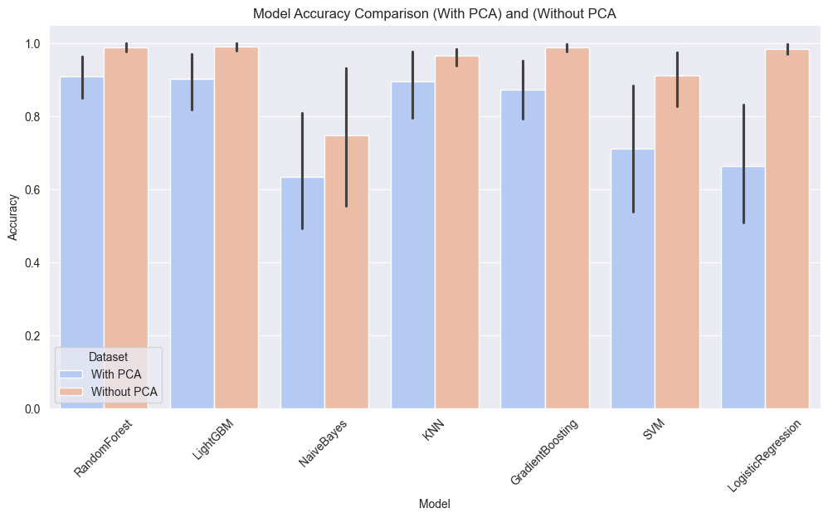
Figure 6 Overall Model Performances
- Note: The error bars in the chart represent the variability in model accuracy, indicating the confidence intervals across multiple runs. Longer error bars suggest higher inconsistency in performance, while shorter error bars indicate more stable accuracy. This visualization helps assess the reliability of each model with and without PCA.

Detailed Comparison and Recommendations

Comparison of PCA vs. Without PCA
- PCA: Reduced computational complexity but resulted in slightly lower performance for some models, especially for complex targets like valve_cond and hyd_accum.
- Without PCA: Achieved higher accuracy and ROC-AUC for most models, especially for complex targets. However, it required more computational resources.

Best Performing Models
- LightGBM: Consistently achieved the highest accuracy and ROC-AUC across all targets, both with and without PCA.
- Random Forest: Robust and performed well for all targets, especially without PCA.
- KNN: Performed exceptionally well for stable_flag and cool_cond.

Worst Performing Models
- Naive Bayes: Struggled with multi-class targets like valve_cond and hyd_accum.
- SVM: Performed poorly for valve_cond and hyd_accum.

Recommendations
- Best Model: LightGBM and Random Forest are recommended for deployment due to their high accuracy, F1-score, and ROC-AUC across all targets.
- KNN is recommended for binary classification tasks like stable_flag.
- Although the computational speed with PCA is fast overall tradeoff between computational performance and accuracy significantly large hence Without PCA is recommended for achieving the highest performance, especially for complex targets.
- Ensemble Methods: Moreover, Ensemble model can be created by Combining models like LightGBM and Random Forest which could yield better results.

